**MOTION DETECTOR LIGHT SYSTEM**

**Team Members:**

1. Muhammad Kamran 20k-0269
2. Bilal Ahmed 20k-0183
3. Mohsin Ahmed 20K-0124

**INTRODUCTION:**

Electricity being an important resource is being wasted in many ways especially when we don’t turn lights off while leaving the room, hence, our main focus was to minimize the electricity consumption by making the lights efficient enough to be turned off and on automatically by detecting the motion within the range of 7 meters. However, another main purpose and our aim to design this project was also to help physically disable people as it can automatically turn on lights when such people enter the room which will make their lives much easier.

**BACKGROUND:**

Project selection was totally based upon our aim to conserve electricity and provide some ease for people with disability. We wanted to design a model which could serve our purpose, hence we researched on different websites to learn about the components and their functionality. We also saw many YouTube videos to clear our problems before starting our project.

**PROJECT SPECIFICATION**

The model includes the following components:

1. PIR sensor (motion detect sensor)
2. Transistors
3. Resistors
4. 5v relay
5. Bread board (optional)
6. 5V Power supply
7. Jumper Wires
8. Light Bulb

**SOLUTION DESIGN:**

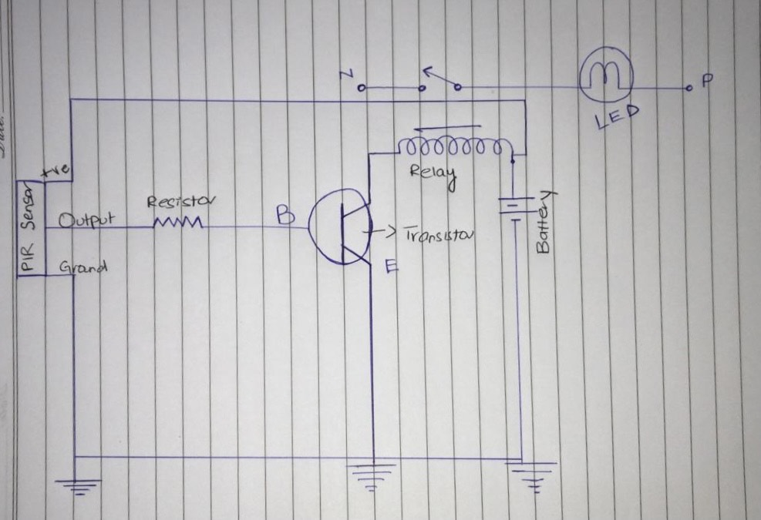

**FUNCTIONALITY:**

As mentioned earlier, it is a motion detect sensor, so when an object or motion is detected by the PIR, it generates a high signal to turn the lights on without using any switch to turn them on manually.

**FEATURES:**

The motion detector light system has the following features:

1. Since the PIR sensor works by absorbing body heat hence it only turns on or off when a human walks in or out.
2. It significantly reduces the amount of electricity being wasted, as it works only when it detects motion.
3. Suitable for people with disability.
4. Can be installed in homes and not only lights, but doors, fans, etc. can also be made automatic. For example automatic door will open when it detect a motion.
5. Further addition of AND gate and LDR can increase its functionality, because LDR will detect the whether its day or night on the basis of sun rays. In case of night a high input will be send to AND gate. Similarly if motion is also detected then PIR will also send a high output to AND gate and this is how output of AND will be high. So in this way lights will automatically turn on when some motion is detected at night time only.

**IMPLEMENTATION AND TESTING:**

The circuit was implemented on a bread board to test it and apply changes if needed. After successful implementation and testing, we connected jumper wires directly with the components to make it as small as possible so that it acquires less space.

Multiple tests were conducted. First by passing our hand inform of PIR sensor, second by moving in front of PIR. All these tests were conducted with multiple ranges of PIR (by adjusting the range of PIR) and then by increasing and decreasing the response time of our PIR. All this was done for proper testing of our model considering all factors.

**PROJECT BREAKDOWN STRUCTURE:**

Our project mainly consists oftwo circuits. One of them is primary circuit consisting of PIR sensor which senses motion and gives it output signal to the relay. The secondary circuit is also attached to the relay which conveys signal from primary to secondary circuit. Hence depending on the output value relays receives from primary circuit it switches the secondary circuit on/off. For example if relay gets a high output from primary circuit (PIR sensor) then it will also generate a high/1 output to turn the secondary circuit (lights or any other device) on. Similarly in case of low/0 output, relay transmits low output to the secondary circuit and doesn’t turn the lights on.

**RESULTS:**

Finally, all these tests we conducted resulted in positive outcome and our model passed all these tests working perfectly regardless of any factor e.g. Response time, distance of motion,

**CONCLUSION:**

Overall, the motion sensor light detection system works efficiently and covers all our aims and motivations we had before starting it. Furthermore, this solution is much feasible and cheaper, to be implemented in various areas such as, corridors, homes, and streets so it can be used over large scale also with low implementation cost making the area/factory/hallways fully automatic and motion controlled.